A473-AM,N-NW-Totem Pole-Watchman-Frog-Whale-Thunderbird-Early 20th century

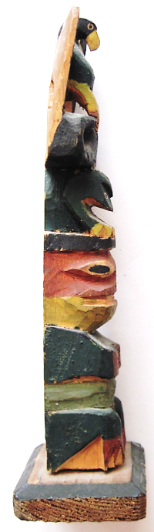 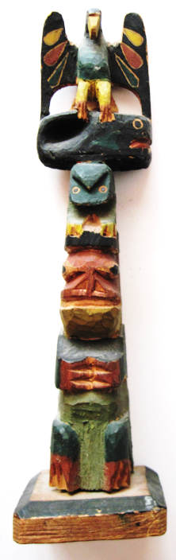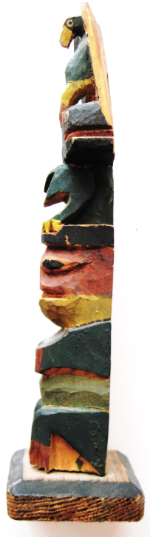

Alaska-Ketchikan-Tlingit-Totem Pole-Frog-Whale-Thunderbird-Early 20th century

**Case no.: 8**

**Accession Number: A474**

**Formal Label:** Alaska-Ketchikan-Tlingit-Totem Pole-Raven-Watchman-1920’s

**Display Description:**

This unusual Tlingit Totem Pole has Raven above Watchman which should be reversed and whale and frog in between. Watchman is pleased that there is no enemy approaching, as that is his duty. Raven has its wings unfurled but is not acting. Raven clearly hhas Whale under control in its talons. Frog is just silent in staring out.

**LC Classification:** E99.T6

**Date or Time Horizon:** Early 20th century

**Geographical Area:** Ketchikan-Alaska

**Map, GPS coordinates:** 55º20'32" N 131º38'46" W

**Cultural Affiliation:** Tlingit

**Media:** Cedar Branch; yellow, pink, gray blue, black, green paint.

**Dimensions:** H 168.04 mm, 6.62 in; W 4056 mm, 1.60 in

**Weight: 44 gm, 1.5 oz**

**Condition: original**

**Provenance:** Ketchikan-Alaska

**Discussion:**

The myth suggests that with Raven ready to respond to danger with its wings unfurled, Watchman can feel relatively at ease. But, one must pay heed to Watchman for his job is to detect danger when it is first identified. Watchman is identified by his round, black cap.

**References:**

Garfield, Viola Edmundson. 1980. *The Seattle totem pole*. Rev. and expanded version. Seattle: University of Washington Press. [20] pages.